**Preprandial and Postprandial Hemodynamics of the Gastroduodenal Artery in Patients Suspected of Chronic Mesenteric Ischemia using 4D Flow MRI**

1G Roberts; 2CJ Francois; 2A Roldán-Alzate; 1,2O Wieben

*Departments of 1Medical Physics, 2Radiology*

*University of Wisconsin – Madison, USA*

**Synopsis:**

Chronic mesenteric ischemia (CMI) causes reduced intestinal blood flow, often from mesenteric occlusions. However, collaterals exist and help compensate for reduced blood flow. This study utilizes 4D flow MRI to quantitatively measure hemodynamics in the gastroduodenal artery (GDA), a collateral between the celiac and superior mesenteric arteries, in controls (N=14) and patients suspected of CMI (N=14) before and after a meal. There was no significant difference in preprandial (p=0.683), postprandial (p=0.538), or change in flow values (p=0.459) between groups. However, pathology-dependent flow patterns were evident within the ischemia group. Follow-up studies with larger cohorts are warranted to verify this finding.

**Introduction:**

Chronic mesenteric ischemia (CMI) is a rare disease caused by reduced blood flow to the intestines, often caused by atherosclerotic lesions in proximal segments of mesenteric vasculature (more than 95% of cases)(1). CMI is characterized by postprandial abdominal pain, occurring shortly after meal ingestion. It is theorized that a “gastric steal” phenomenon is responsible for the relatively early onset of pain, in which blood is temporarily shunted from the superior mesenteric artery (SMA) to the celiac artery (CA) in order to accommodate increased gastric blood flow demand, ultimately leading to downstream vasoconstriction, ischemia, and pain in individuals with compromised splanchnic circulation(2). The pancreaticoduodenal arcades (PDA), a collateral between the SMA and CA, is a primary pathway in this process. Additionally, it is known that this pathway serves as a major collateral in patients with celiac stenoses(3). However, blood flow patterns in this collateral artery have not been well studied in CMI patients. This study utilizes 4D flow MRI to quantitatively measure hemodynamics in an arterial segment in the PDA, the gastroduodenal artery (GDA), in controls (N=14) and patients suspected of CMI (N=14) before and after a standardized meal.

**Methods**:

In this patient-compliant and IRB-approved study, 20 healthy volunteers (age range 19-73y, mean=44y, females=8) and 19 patients (age range 21-86y, mean=50y, females=14) with a suspicion of mesenteric ischemia were imaged on clinical 1.5T and 3.0T scanners (GE Healthcare, Waukesha, WI). For all subjects, 4D PC MR data were acquired before and after ingestion of a meal using radially-undersampled PC-VIPR acquisition(4, 5) with full volumetric coverage of the upper abdomen: imaging volume: 32x32x24cm spherical; 1.25mm isotropic resolution; TR/TE=6.6-8.3ms/1.9-2.7ms; tip angle=6-15°; Venc=100-120cm/s; intravascular contrast agent (0.03mmol/kg gadofosveset trisodium (Lantheus, N. Billerica, MA)); with retrospective ECG and respiratory gating. Pre-prandial imaging was performed after 5 hours of fasting. After the first scan, subjects orally ingested 474 mL EnSure Plus® (Abbot Laboratories, Columbus, OH) and scanning resumed 20 minutes after ingestion. 3D vessel segmentation from the PC data was performed using Mimics (Materialize, Leuven, Belgium). Ensight (ANSYS, Canonsburg, PA) was used for cut-plane placement and flow visualization in the GDA. Cut-planes were exported to a customized software package(6) for manual temporal segmentation throughout the cardiac cycle.

After data analysis, diagnoses for the patient group were given. The patient group was then subdivided into a true CMI group and negative diagnosis group based on these diagnoses. GDA flow was compared between each subgroup using a two-tailed Welch t-test. For all statistical tests, p<0.05 was chosen to reflect statistical significance.

**Results:**

4D flow data were successfully obtained for all 39 subjects and the GDA was visualized in 28 of these patients. Average flow rates and percent change in flow values for each group are summarized in Table ?.

|  |  |  |  |
| --- | --- | --- | --- |
| **Group** | Average Preprandial Flow Rate (mL/min) | Average Postprandial Flow Rate (mL/min) | % Change |
| Control | 76.3 ± 37.0 | 88.6 ± 50.3 | 14.3 ± 33.1 |
| Negative Diagnosis | -2.54 ± 161 | 103 ± 210 | -54.5 ± 61.6 |
| Ischemia | 154 ± 548 | 219 ± 429 | 3.32 ± 150 |

**Discussion:**

**Conclusion:**

**References:**

1. Sreenarasimhaiah J. Chronic mesenteric ischemia. Best Pract Res Clin Gastroenterol 2005;19:283–295.

2. Poole JW, Sammartano RJ, Boley SJ. Hemodynamic basis of the pain of chronic mesenteric ischemia. Am J Surg 1987;153:171–6.

3. Song S-Y, Chung JW, Kwon JW, et al. Collateral Pathways in Patients with Celiac Axis Stenosis: Angiographic–Spiral CT Correlation. RadioGraphics 2002;22:881–893.

4. Gu T, Korosec FR, Block WF, et al. PC VIPR: A high-speed 3D phase-contrast method for flow quantification and high-resolution angiography. AJNR Am J Neuroradiol 2005;26:743–749.

5. Johnson KM, Markl M. Improved SNR in phase contrast velocimetry with 5-Point balanced flow encoding. Magn Reson Med 2010;63:349–355.

6. Stalder AF, Russe MF, Frydrychowicz A, Bock J, Hennig J, Markl M. Quantitative 2D and 3D phase contrast MRI: optimized analysis of blood flow and vessel wall parameters. MRM 2008;60:1218–1231.

**Figures:**

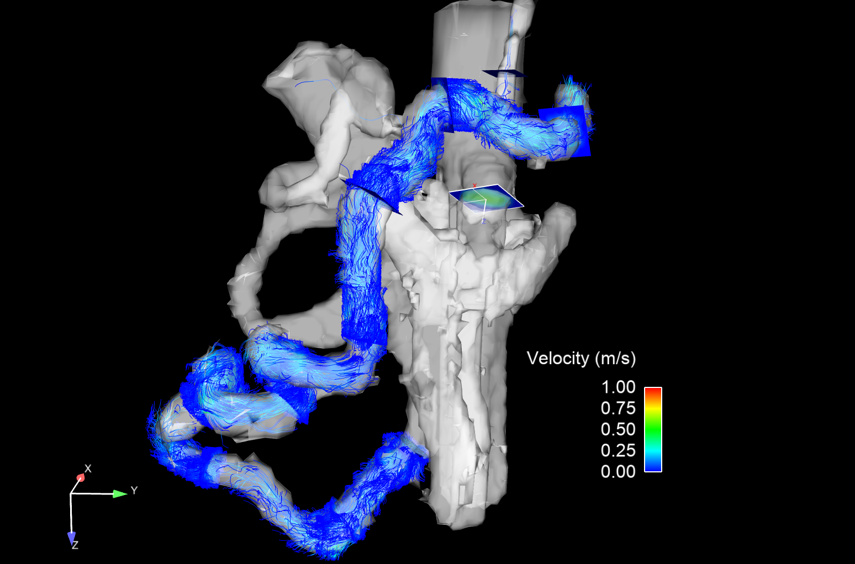

Pancreaticoduodenal arcades

GDA

Proximal SMA

Left gastric artery

Splenic artery

Distal SMA